Long-term monitoring status of Antarctic nearshore marine and terrestrial flora and fauna

Long-term monitoring status of Antarctic nearshore marine and terrestrial flora and fauna
Summary
Parties have long recognised the importance of monitoring for achieving the goals of the Environmental Protocol. A systematic assessment of nearshore marine and terrestrial nearshore biodiversity monitoring shows that most focus has been on penguins and seals, though concentrated in some regions of the continent and sparse in others. Monitoring of plants and invertebrates is much less common despite their importance for understanding change. New automated methods offer effective ways to improve continent-wide monitoring to support decision-making.
Background
Environmental monitoring has long been of importance to the Parties as reflected in early discussions (ATCM15 WP21), and recent activities such as those of the Intersessional Contact Group on an international framework for environmental monitoring (ATCM47 WP6). Identification of long-term change in the biodiversity of nearshore marine and terrestrial biota can inform management practices for species, communities and ecosystems which may be vulnerable or at risk, enabling Parties to recommend actions to mitigate risks (ATCM45 IP045).
Reflecting its utility for informing decisions, monitoring of long-term ecosystem change has become a priority in both the CEP Five-Year Work Plan and the Climate Change Response Work Programme, and a primary topic of discussion for the joint workshops of the CEP and SC-CAMLR (ATCM47 WP37), including the upcoming joint workshop in association with ATCM 48.
To improve long-term monitoring efforts for decision-making, understanding of the current scope of monitoring and the variables (parameters and/or indicators) being monitored is essential (ATCM47 WP6).
This paper summarises the findings of a synthetic review of published studies on the monitoring of fauna and flora conducted in Antarctic terrestrial and nearshore marine environments.
Key findings
Around Antarctica, nearshore and terrestrial long-term monitoring efforts are concentrated along the western Antarctic Peninsula and Scotia Arc (Figure 1). The focus on this region likely reflects ease of accessibility to sites, as well as more ice-free areas on the peninsula (ATCM XL IP084). Although the overall number of studies reporting monitoring for ≥3 years is limited (136), more than half of these provided data extending >10 years. Only 10% of monitoring sites are located within Antarctic Specially Protected Areas (ASPAs).
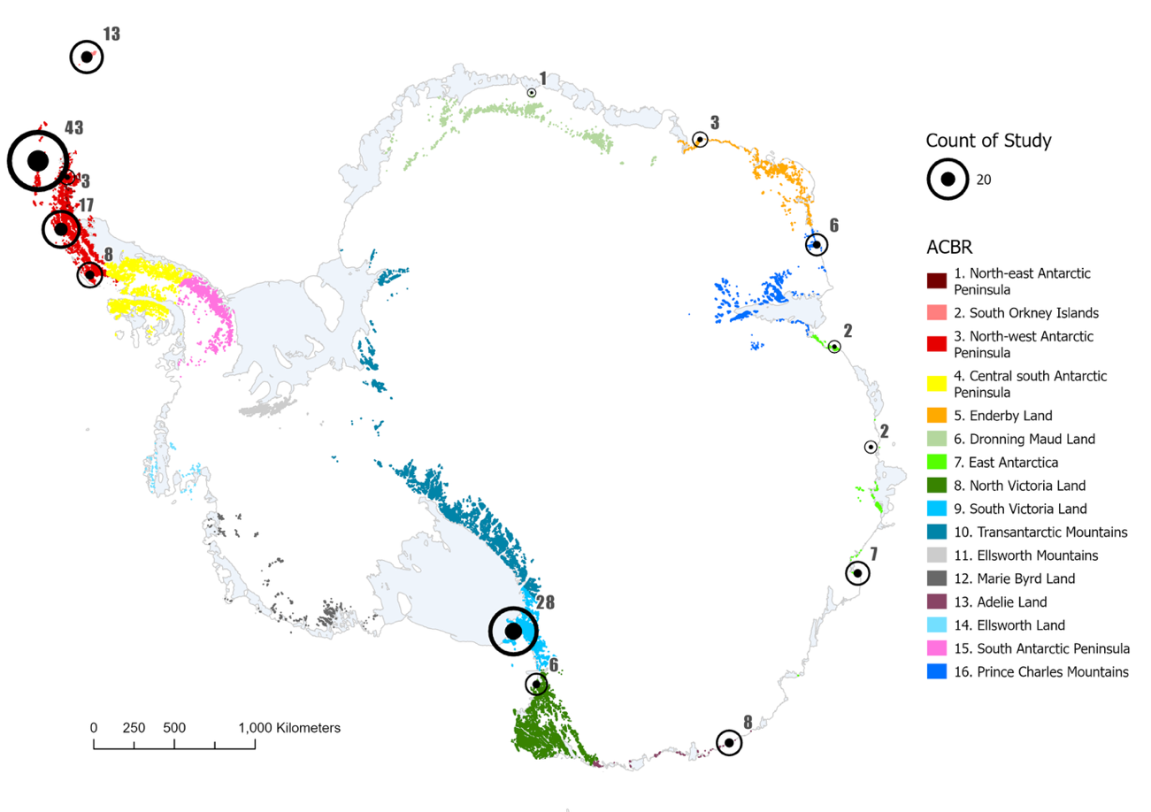
Figure 1 - Map of nearshore and terrestrial long-term monitoring locations across Antarctica in relation to the 16 Antarctic Conservation Biogeographic Regions (ACBR). Dot size is relative to the number of studies at a given location. Reproduced from Jones et al. (2025).

Most monitoring is focused on birds and mammals (~65%). By contrast, smaller or cryptic terrestrial groups, such as mosses, lichens, fungi, invertebrates and microbes are less commonly monitored (<15% of studies), despite their significance in Antarctic ecosystems (Figure 2).
Species abundance is the most measured parameter across all taxonomic groups, while <10% of studies measure factors that account for health changes (e.g. growth rate, physiology, phenology). Monitoring studies often deploy different methodologies, including for the same parameters, complicating comparisons among them because methods are not standardised.
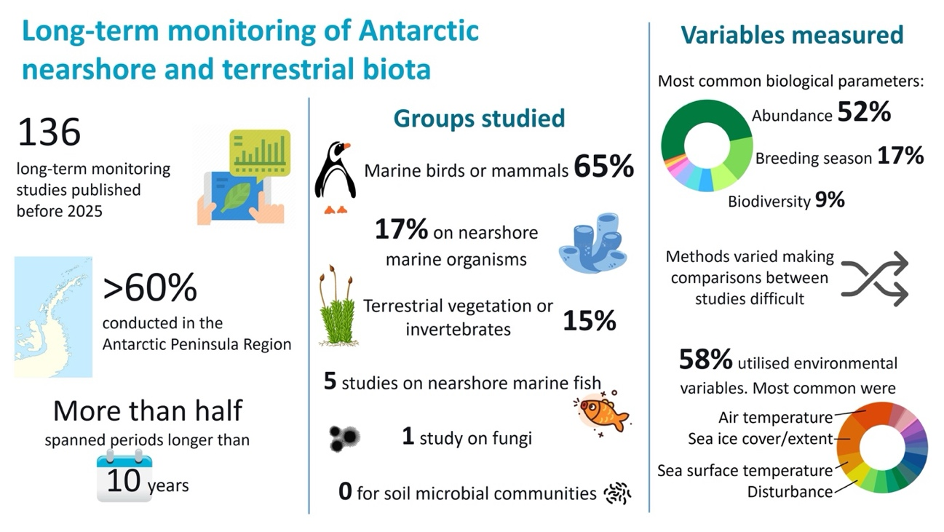
Figure 2 - Synopsis of long-term monitoring studies of Antarctic nearshore and terrestrial biota. The most common biological parameters measured were 1) abundance, 2) breeding season, and 3) biodiversity, which included species composition, species richness, community structure and taxonomic surveys. Of the 136 long-term studies on Antarctic biota, only 58% attempt to measure and/or use environmental covariates alongside measured biological parameters to attribute change. Reproduced from Jones et al. (2025).

Based on these findings, several improvements could readily be implemented to improve the value of long-term monitoring in Antarctica (Figure 3). These include:
- Improving consistency of data collection and the development of new approaches to improve comparability;
- Increasing representation of the entire ecosystem and all taxonomic groups, and establishing sentinel sites to ensure coverage of Antarctica is adequate both spatially and biologically (Appendix 1, see also ATCM47 IP057, ATCM47 IP072, ATCM47 IP147, WS-CC-2023/15);
- Coordinating biological monitoring with continuous collection of environmental data (e.g., temperature, sea ice extent) at appropriate spatial scales (Appendix 2, see ATCM45 WP49);
- Sharing of data under FAIR principles, and collaboration to enable more complete and robust comparisons over time (see ATCM45 WP49).
With rapid environmental changes already underway in polar ecosystems (Abram et al. 2025), the next decade is a decisive period for consolidating and establishing long-term ecological baselines. The upcoming International Polar Year (2032–33) and coordinated research efforts such as Antarctica InSync (2027–30) offer ideal platforms to unify efforts, share resources, and establish a durable legacy of environmental stewardship.
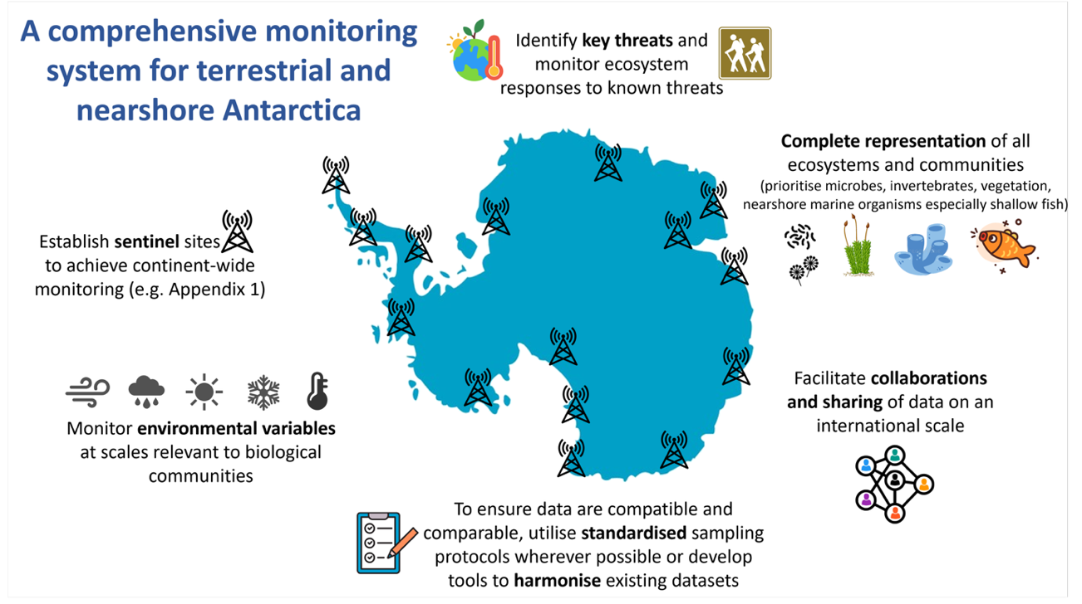
Figure 3 - Recommendations for improved long-term monitoring of Antarctic nearshore and terrestrial ecosystems based on the current limitations and gaps in published long-term monitoring studies. Modified from Jones et al. (2025).

Recommendations
Given these findings SCAR recommends that the Committee encourages Members to:
- Support the commitment of national resources to existing and new nearshore and terrestrial monitoring programs;
- Support alignment of ongoing research programs in meteorology, climate science and biology to improve understanding of the drivers of biodiversity change and strengthen options and decisions for mitigation;
- Utilise advances in automated sensing and analysis platforms, alongside new capabilities in AI and machine-learning, to monitor environments in real-time (e.g., ANTOS, INACH Red and SAEF AIoT) improving responses and decision-making options and supporting more informed and responsive management decisions;
- Collaborate, including with COMNAP and SCAR, to leverage upcoming international programs (the 5th IPY and Antarctica InSync) to develop a sustained, circum-Antarctic platform for assessing environmental change and biodiversity responses, thereby strengthening the evidence needed to deliver the goals of the Protocol.

References
Abram, N.J., Purich, A., England, M.H., McCormack, F. S., Strugnell, J. M., Bergstrom, D. M., et al. (2025). Emerging evidence of abrupt changes in the Antarctic environment. Nature 644:621–633. https://doi.org/10.1038/s41586-025-09349-5
ATCM15 WP21 (1989). Environmental Monitoring in Antarctica Working Paper. Antarctic Treaty Consultative Meeting XV. Paris, France.
ATCM XL/IP084 (2017) Climate change impacts on Antarctic ice-free areas. Information Paper. Antarctic Treaty Consultative Meeting XL. Beijing, China.
ATCM45 IP045 (2023). Managing threats to Antarctic terrestrial biodiversity. Information Paper. Antarctic Treaty Consultative Meeting XLV. Helsinki, Finland.
ATCM45 WP049 (2023). Antarctic Nearshore and Terrestrial Observing System (ANTOS). Working Paper. Antarctic Treaty Consultative Meeting XLV. Helsinki, Finland.
ATCM47 WP6 (2025). An international framework for environmental monitoring - Report of the ICG and way forward. Working Paper. Antarctic Treaty Consultative Meeting XLVII. Milan, Italy.
ATCM47 WP37 (2025). Preparation of the next Joint CEP/SC-CAMLR climate change and monitoring workshop. Information Paper. Antarctic Treaty Consultative Meeting XLVII. Milan, Italy.
ATCM47 IP147 (2025). Informing systematic protection of Antarctic terrestrial vegetation. Information Paper. Antarctic Treaty Consultative Meeting XLVII. Milan, Italy.
ATCM47 IP57 (2025). A multidimensional assessment of Antarctic terrestrial biological data. Information Paper. Antarctic Treaty Consultative Meeting XLVII. Milan, Italy.
ATCM47 IP72 (2025). A dataset of Antarctic ecosystems in ice-free lands: classification, descriptions, and maps. Information Paper. Antarctic Treaty Consultative Meeting XLVII. Milan, Italy.
INACH Red Latitudinal de Estaciones Multiparametricas en Antarctica, (https://www.redsensoresinach.cl)
Jones, S. L., King, D. H., Cummings, V., Robinson, S. A., and Waterman, M. J. (2025) Research bias in long-term monitoring of Antarctic nearshore marine and terrestrial biota. Global Change Biology 31:e70392. https://doi.org/10.1111/gcb.70392
Securing Antarctica’s Environmental Future (SAEF) Artificial Intelligence of Things (AIoT) Platform and dashboard, https://uow.info/mosscam
WS-CC-2023/15 Cummings, V.J., Lohrer, D. 2023. Taking climate change effects on benthos into account in CCAMLR. Paper to CCAMLR workshop on climate change (ccamlr.org)
Appendix 1
Recommended sites based on ANTOS Survey (II). Sites are categorized into (Column 1) those experiencing rapid change and (Column 2) those with existing research infrastructure and advocates for further research. Column 3 lists ACBRs where no Survey respondents reported monitoring or support for sites. Sites with a fish symbol represent marine sites, those with a plant symbol denote terrestrial sites, and sites with both symbols have both marine and terrestrial monitoring. (Reproduced from Borgmeier et al. 2025; https://scar.org/science/cross/antos). See also ATCM47 IP147 Fig A3 for other important sites for monitoring terrestrial biodiversity.
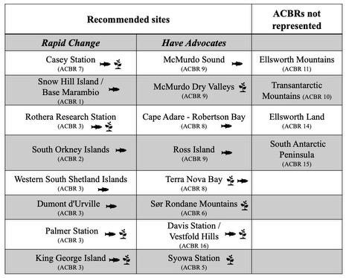

Appendix 2
Climate sensing stations that have been established in Antarctica by the Instituto Chileno Antarctico (INACH). Several are potentially good locations for biodiversity assessments and long-term monitoring as identified in Appendix 1. (INACH Red Latitudinal de Estaciones Multiparametricas en Antarctica; https://www.redsensoresinach.cl).
Climate Station | Location (coordinates) | Climate Station | Location (coordinates)
Base J | Lat:-66.008, Lon:-65.339 | Glaciar Unión | Lat:-79.768, Lon:-82.912
Base O’Higgins | Lat:-63.322, Lon:-57.898 | Isla Livington | Lat:-62.68, Lon:-60.412
Base Prat | Lat:-62.479, Lon:-59.664 | Islote Alcock | Lat:-64.24, Lon:-61.131
Boonen Rivera | Lat:-63.538, Lon:-57.406 | Islote D hainaut | Lat:-63.903, Lon:-60.793
Cabo Melville | Lat:-62.021, Lon:-57.624 | Monte Vinson | Lat:-78.523, Lon:-85.557
Carvajal | Lat:-67.776, Lon:-68.867 | Peñón Escuela de Montaña | Lat:-79.792, Lon:-82.987
Escudero | Lat:-62.203, Lon:-58.962 | Pta.Py | Lat:-64.878, Lon:-63.591
Gabriel González Videla | Lat:-64.824, Long:-62.858 | Punta Armonía | Lat:-62.304, Lon:-59.197

