Antarctic Climate Change and The Environment: 2026 Update

Antarctic Climate Change and The Environment: 2026 Update
Summary
This paper provides an update on climate change related developments since ATCM47–CEP27. Themes emerging from recent research are: (1) increasingly detailed understanding of regional differences in the way change in the Antarctic will occur; (2) without a reduction in emissions, Antarctic environments will continue along a pathway of substantial changes, where it is increasingly likely that these changes will be unable to be reversed even within centuries. SCAR encourages Antarctic Treaty Parties to widely communicate the need for emissions reductions to maintain Antarctic values, and to continue to support research to understand the future of the Antarctic in an Earth System context.
Introduction
In keeping with the requests by the Parties, SCAR delivers annual updates on Antarctic climate change and its implications between its major, decadal, reports. The update provided here is not a comprehensive synthesis. Rather, it reports key developments in understanding of climate change in the Antarctic, its drivers and implications for the region and/or for the globe, and their relevance to the work of the ATCM and the CEP. A separate paper considers sea ice in detail (WP032).
Abrupt changes
Key message: Abrupt changes are already underway in the Antarctic region with others on the verge of taking place.
Recent abrupt changes in the Antarctic physical and living environments, and their feedbacks, have now been reviewed comprehensively. A regime shift has reduced Antarctic sea-ice extent far below its natural variability of past centuries. The tipping point for unstoppable ice loss from the West Antarctic Ice Sheet could be exceeded even under best-case CO₂ emission reduction pathways (acknowledging uncertainties). Regime shifts are likely underway in marine systems and breeding failures are increasing extinction risk for certain species. Positive feedbacks are common between these abrupt changes (Figure 1). Stabilizing Earth’s climate at or below 1.5°C warming is imperative alongside adaptation measures to minimize and prepare for the impacts of abrupt changes. In 2025, global average surface temperature was 1.44°C ± 0.13°C above the 1850-1900 average.

Sea Ice
Key message: Sea-ice extent has continued to decline, with both the drivers and implications of the change becoming clearer.
Antarctic sea-ice extent was much lower in 2025 than in the observed period prior to 2015. Modelling, and observational studies , point to ocean heat content and atmospheric circulation as major among the contributors to sea ice decline.
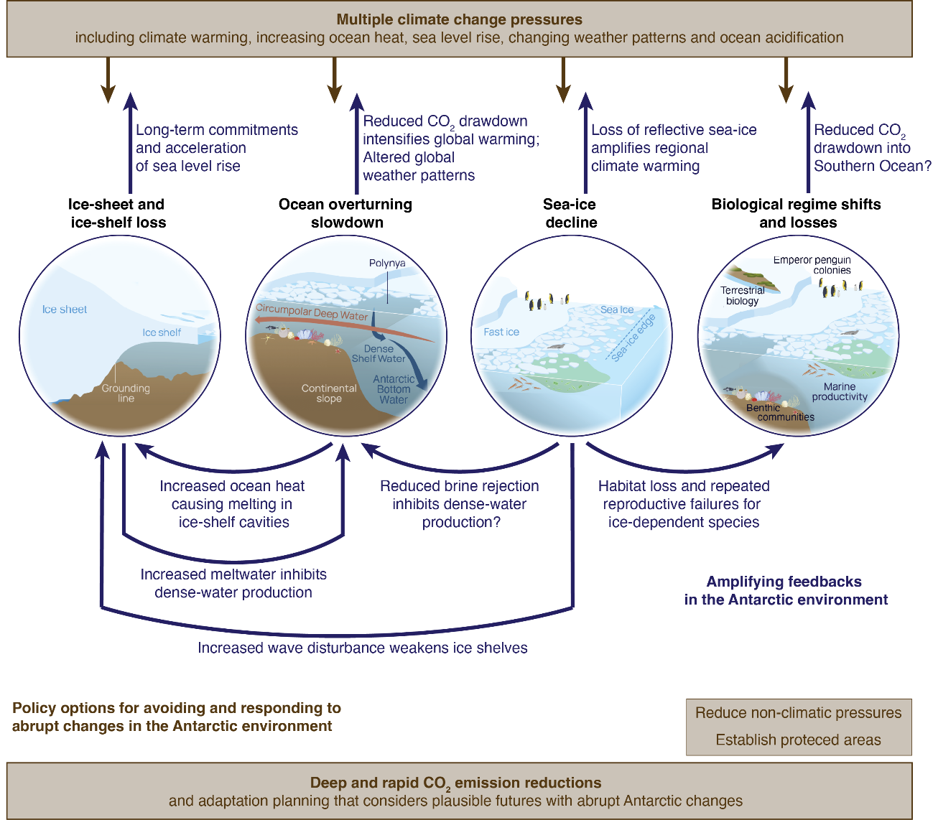

Figure 1 - Abrupt changes in the Antarctic environment. Courtesy Nerilie Abram and collaborators.

Ocean
Key messages: Future West Antarctic Ice Sheet retreat will likely reduce carbon uptake in the Pacific sector of the Southern Ocean, in a positive feedback loop. Polynya change may have significant consequences.
The Southern Ocean acts as an important CO₂ sink. Iron plays a key role in this process because primary productivity in the Southern Ocean is iron limited. Recent work demonstrates that millennial-scale variations in West Antarctic Ice Sheet (WAIS) dynamics have controlled both the supply and bioavailability of particulate iron in the Pacific Antarctic Zone over the last 500 000 years. During periods of pronounced ice loss, iron bioavailability and CO₂ uptake are low. This positive ‘ice-sheet–iron feedback’ suggests that future WAIS retreat is likely to decrease carbon uptake in the Southern Ocean because of an expected decline in primary productivity.
Polynyas (areas of persistent open water) contribute substantially to biological activity including carbon uptake, and play important physical roles in the region. For example, polynyas contribute 10% of total Antarctic sea ice growth. Although observational data show a linear increase in the size of nearly all Antarctic coastal polynyas since 1979, projections suggest a decline in polynya extent and activity with future warming.
Atmosphere
Key messages: Surface melting of the Antarctic Ice Sheet is widespread. CO₂ outgassing south of 50°S has been underestimated by up to 40%, with implications for global carbon budgets.
Projections show that surface melt (Figure 2) will likely have an increasing influence on Antarctic Ice Sheet (AIS) mass loss. Understanding of such surface melting is, however, limited. A 15-year (2002-2026) data set estimated surface meltwater area at 3 732 km² for Antarctica (Figure 3): more pronounced in East Antarctica and the Antarctic Peninsula than West Antarctica. Increased surface meltwater, combined with ocean-induced melting, significantly raises the risk of ice shelf instability. Most ice shelves are likely to remain stable under low-emission scenarios.

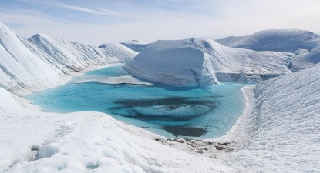
Figure 2 - Surface meltwater on the Nivlisen ice shelf, Dronning Maud Land, 2026. Image: SL Chown.
The Southern Annular Mode (SAM) is now in its most positive mean state in over 1 000 years, with a continued positive trend projected throughout the twenty-first century in response to increasing greenhouse gases, with a range of physical and biogeochemical effects on the region. These include enhanced CO₂ outgassing (exchange from the ocean to the atmosphere). New research has shown that the contribution to CO₂ outgassing from the area south of 50°S has been underestimated by 40%, with major implications for global carbon budget assessments
Antarctic Ice Sheet (AIS) and Sea Level
Key message: Ice loss in several ice catchment basins faces thresholds for loss as low as 1-2°C, including in East Antarctica, emphasising the value of keeping global warming below 2°C above pre-industrial levels.
A recent investigation provides insights into the likelihood of and conditions for abrupt change for all of the ice drainage basins of the Antarctic. Depending on topographic and climatic conditions, ice loss in some basins is characterized by a critical threshold or tipping point beyond which large parts eventually disintegrate, whereas in other basins, ice loss unfolds gradually with warming. A first threshold, potentially as low as 1–2 °C above pre-industrial levels, is projected to trigger the long-term collapse of ~40% of marine ice volume in West Antarctica. Marine-based sectors in East Antarctica, representing ~5 m of potential sea-level rise, are at risk of losing stability between 2–5 °C of warming (Figure 4).

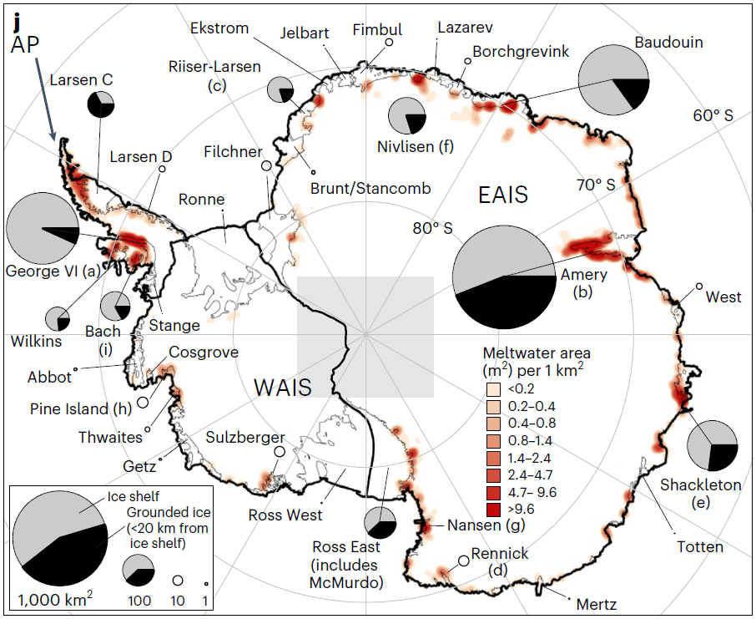

Figure 3 - Surface meltwater across Antarctica. The grey square indicates area not mapped. Image supplied by Pete Tuckett, Creative Commons License: http://creativecommons.org/licenses/by/4.0/
Much uncertainty still exists, however, about the processes underlying rapid change. For example, the Hektoria Glacier on the Eastern Antarctic Peninsula retreated ~25 km between 2022 and 2023. Retreat in the November–December 2022 period was 8.2±0.2 km in two months – a rate ~10x faster than published values. Retreat resulted primarily from a process related to specific sub-ice geometry, suggesting that marine-terminating glaciers with such geometry can be easily destabilized. Observational and modelling studies are essential to reduce uncertainties.
Marine Biodiversity
Key message: Antarctic marine biodiversity continues to show strong signals of change in abundance, distribution and species composition.
Recent modelling has indicated that under high-emission scenarios, krill habitats face severe contraction and loss between 1991 and 2100. Greater resilience through to 2100 is more likely under low-emission scenarios. Projected habitat suitability differs for Antarctic krill in different CCAMLR areas between 2030 and 2100. The work concludes that protecting krill habitats is essential due to krill’s important role in the ecosystem and carbon cycle.

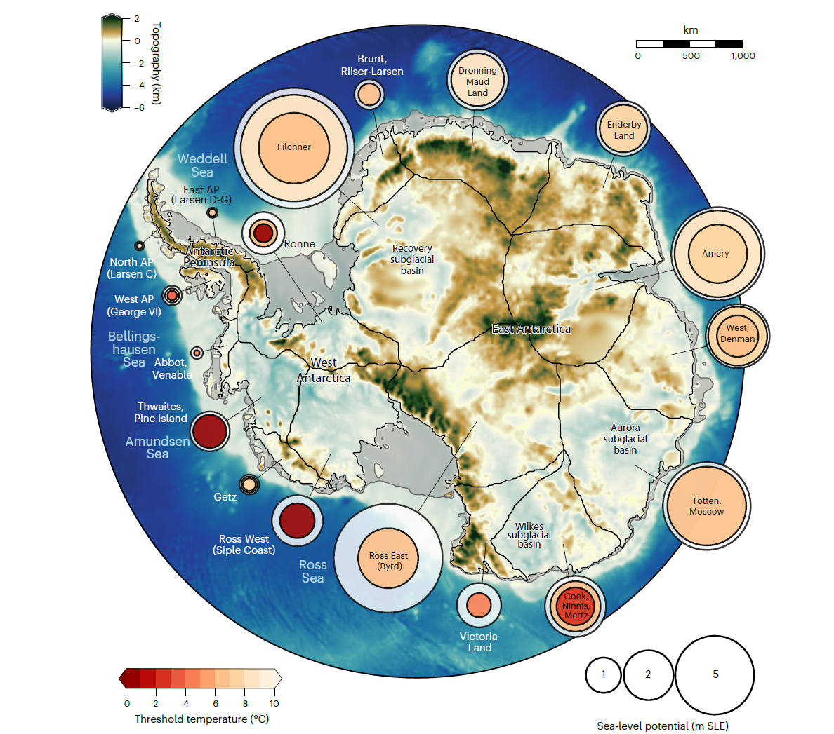

Figure 4 - Risk map of Antarctic ice catchment basins.¹⁵ Nested circles show critical temperature for strongest ice loss (circle colour) and proportion of ice volume lost long-term after crossing the thresholds (circle size). Background shading shows bedrock topography. Image reproduced under a Creative Commons License: http://creativecommons.org/licenses/by/4.0/
Research on marine predators continues to highlight the importance of sea ice change for the abundance of seals and whales,, and the additional effects of HPAI on seals. Across the Antarctic Peninsula, a network of cameras monitoring Adélie, Chinstrap and Gentoo penguins has shown that colony locations are warming 4x faster (0.3°C/year) than the average (0.07°C/year), and that the start of the breeding season has advanced at record rates: 10-13 days/decade between 2012 and 2022.
Terrestrial Biodiversity
Key message: Antarctic terrestrial biodiversity is changing, with responses varying between biogeographic regions and species groups.
While understanding of Antarctic biodiversity change continues to improve, terrestrial biodiversity remains one of the continent’s most poorly investigated subjects; nonetheless, studies show ongoing change, contingent on the geographic area.
For rock-dwelling (lecideoid) lichens, a reduction in suitable habitat area is expected in maritime Antarctica, but an expansion in continental regions owing to ameliorating environmental conditions. With invertebrates, habitat type, the specific group of animals, and geographic location all affect the way abundances respond to environmental change, suggesting some complexity for projections.
Five hypotheses for terrestrial Antarctic biodiversity outcomes under global change provide a useable framework for reducing complexity and as a guide for monitoring (Figure 5). Evidence shows that physical conditions will likely remain a dominant constraint to fitness, even in warmer, wetter situations.
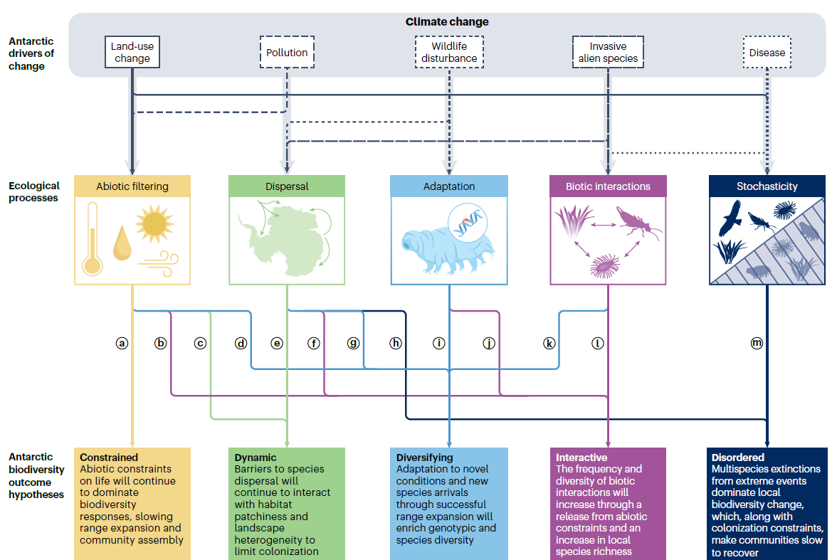
Figure 5 - The ecological processes and their interactions that underpin terrestrial Antarctic biodiversity change.²⁴ Abiotic filtering means the effect of physical factors. Biotic interactions include predation, parasitism, competition and mutually beneficial functions. Figure from McGeoch et al. Ecological processes shaping Antarctic terrestrial biodiversity change,²⁴ Springer Nature, licensed with permission from SNCSC (6231570182063).
Recommendations
SCAR encourages Antarctic Treaty Parties to continue their efforts to support research to understand the changing Antarctic environment across physical and living systems. As recommended in the ACCE Decadal Synopsis, clear communication to a wider audience of a changing Antarctic and its Earth System implications remains an important way to ensure that ongoing impacts to the region are understood and reduced.

Chown et al. 2022. Antarctic Climate Change and the Environment: A Decadal Synopsis and Recommendations for Action, www.scar.org
Abram et al. 2025. Nature https://doi.org/10.1038/s41586-025-09349-5
WMO. 2026. https://wmo.int/news/media-centre/wmo-confirms-2025-was-one-of-warmest-years-record
Kusahara & Tatebe. 2025. Geophys Res Lett https://doi.org/10.1029/2025GL115256
Chan et al. 2025. Geophys Res Lett https://doi.org/10.1029/2025GL116688
Purich & Doddridge. 2023. Comms Earth Environ https://doi.org/10.1038/s43247-023-00961-9
Boehm. et al. 2025. Comms Earth Environ https://doi.org/10.1038/s43247-025-02792-2
Struve, T. et al. 2026. Nature Geosci https://doi.org/10.1038/s41561-025-01911-0
DuVivier et al. 2026. Nature Comms https://doi.org/10.1038/s41467-026-69011-0
Golledge et al. 2025. Nature Rev Earth Environ https://doi.org/10.1038/s43017-024-00634-x
Tuckett et al. 2025. Nature Climate Change https://doi.org/10.1038/s41558-025-02363-5
Jourdain et al. 2025. The Cryosphere https://doi.org/10.5194/tc-19-1641-2025
Purich et al. 2026. Nature Rev Earth Environ https://doi.org/10.1038/s43017-025-00746-y
Zhang et al. 2025. Science Advances https://doi.org/10.1126/sciadv.aea0024
Winkelman et al. 2026. Nature Climate Change https://doi.org/10.1038/s41558-025-02554-0
Ochwat et al. 2025. Nature Geosci. https://doi.org/10.1038/s41561-025-01802-4
Cui et al. 2025. Marine Pollut Bull https://doi.org/10.106/j.marpolbul.2025.118142
Dunn et al. 2025. Global Change Biol https://doi.org/10.1111/gcb.70290
Charlton et al. 2026. Scientific Rep https://doi.org/10.1038/s41598-026-36897-1
Bamford et al. 2025. Comms Biol https://doi.org/10.1038/s42003-025-09014-7
Martinez et al. 2026. J Animal Ecol https://doi.org/10.1111%2F1365-2656.70201
Götz et al. 2025. Global Change Biol Comms https://doi.org/10.1002/gcb4.70000
Klarenberg et al. 2026. Ecography https://doi.org/10.1002/ecog.08175
McGeoch et al. 2026. Nature Rev Biodivers https://doi.org/10.1038/s44358-025-00113-1

