Tips to create Stories
I The stories are in “Past”
Aim : To use “Past Tenses” by showing a full command of them.
Bibliography : Essential Grammar in Use . 4th edition. ( Red book)
English Grammar in Use . 4th edition. ( Blue book)
Both books have won “ The world’s best – selling grammar series”

Understanding | Vocabulary | Grammar | Pronunciation | Fluency | Content

I Past Tenses
1.- To Be in Past = Was /Were ( Unit 11)
Example : The Trip to Hawaii was wonderful.
2.- Past Continuous = … Was/ Were + V-ing.. ( Units 13 and 14 )
Example : Peter was driving when suddenly an UFO came up.
3.- Past Simple Tense = S + Vpast ( regular and irregular Verbs) + C. ( Units 11 and 12 Red book )
a.- Regular V-ed Irregular Verbs : Memorize them!! ( 2nd column of verbs)
b.- This is the most important Tense to create a Story since it is
_{the supporting tense.}
Examples : The accident happened because George was driving carelessly.
4.- Past Perfect Tense = … Had + Vpast participle ( regular and irregular Verbs) Units 15-16 Blue book)

a.- Regular V-ed Irregular Verbs : Memorize them!! ( 3rd column of verbs)
Example : Peter and Mary were very afraid because they HAD never SEEN ( nunca habían visto) an UFO.
5.- Passive Voice in past = … Was/were + Vpast participle ( regular and irregular Verbs) (Units 21 and 22 Red book) (Units 42- 46 Blue book)
Examples : Peter was arrested by the Police.
The notice/ warning was blown by the wind.
6.- COULD = poder in past ( Unit 30 Can v/s Could) ( Unit 27 Blue book)
Example : Harold Couldn´t open his flat because he had lost the key.

II Expressions
Yesterday
Last year/week/ weekend/ month/ Summer/ Autumn (Fall) Winter/Spring, etc.
Ago : Two weeks ago, five years ago, three months ago, etc.
Suddenly
Fortunately
Unfortunately
Oh Surprise!!
Such a …
…used to
Evidently
Certainly
Obviously

Speaking of emotions, make sure to include your own. Captivating stories don’t just share what happened and when — they also reveal how you felt, what motivated you, what drove you on, etc. The more emotion you can include in your story, the better, although it doesn’t have to be complicated. Try something as simple as:
He/ she was panicking.
She/he couldn’t believe it!
The news was devastating.

If you create an emotional connection with your listeners, they’ll be hanging on your every word.

III Connectors
SEQUENCE CONNECTORS

.
First, then, next , later, before, after that, finally . And, or, but, so. While, when, at first, when, in the end, afterwards.

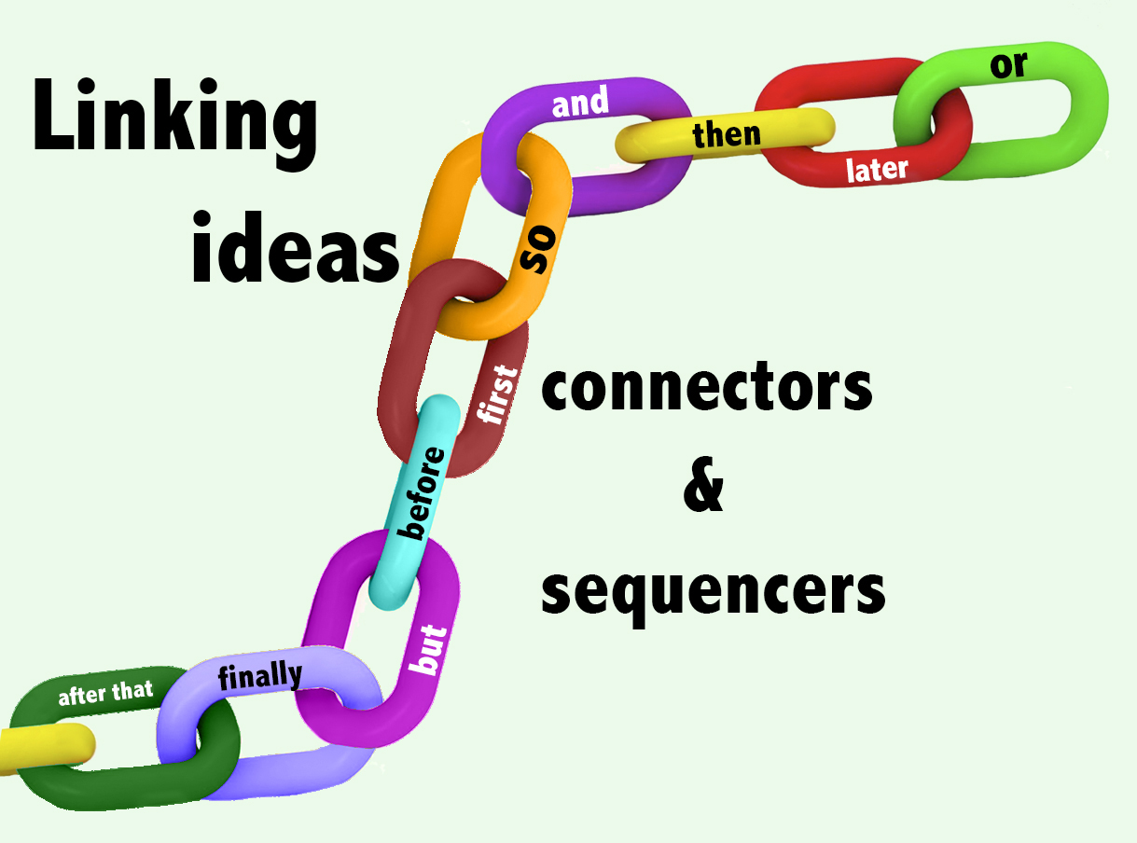

Sequence connectors
The main function of connectors in English grammar is to join words or sentences of what you want to express. The correct usage of connectors gives coherence to what you write or express orally. In addition to joining words, sentences or paragraphs, the sequence connectors are very helpful to organize your ideas when you want to tell someone what happened at a particular time in a logical sequence.

Connectors | Function | Example
and | Is used to add another idea or concept. | I ate a tasty a crepe and we went to the hotel.
or | Introduces one or more alternatives. | I watched TV or read some of travel guides.
but | Introduces an exception or a contrast. | We stayed there for three weeks but we were too tired in the first day.
because | Demonstrates the reason for something. | I had to stay in bed because I was sick.

Connectors | Function | Example
first | Introduces the first of a sequence. | First, I went to Paris.
then | Introduces the next action or concept. | Then we took a boat.
later | Introduces the next action or concept. | We took a train, later we went to Spain.
after | That also introduces another action or concept. | After that, I proposed to go to Barcelona.
before | Demonstrates a previous action or concept. | Before we leave Europe we visited Barcelona.
finally | Demonstrates the last action or concept. | Finally, my friends and I decided to stay in Barcelona.

Using Connectors and Words that Add to Ideas.

The library on 5th Avenue in New York City is one of the best places to do research. It has hundreds of the most respected magazines and journals in the world.

Look at these two sentences. Is there anything wrong with them? There is nothing wrong with them, but a word that connects these two sentences is often added. Adding a connector would clearly show a relationship between the two sentences and ideas.
Connectors are words that are commonly used in professional, business, and university writing. Although the words have different grammatical names, they share one thing in common: they all continue or add to ideas that were written in the preceding sentence.
Additionally, | Besides that, | Not only...but also
Also | Furthermore, | Too
And | In addition,
As well | Moreover,

These words are not interchangeable. In other words, you cannot remove one of these words and add any other. The best way to explain how to use these words is simpler by giving you examples. One thing they all have in common is that they are usually attached to clauses. That means they are attached to a group of words that contains a subject and a verb.
Let`s use the same sentences in order to illustrate how the words are used and to show their different positions in the sentences. The positions of the words that here are shown are the most common but not necessarily the only positions.
Moreover,
The library on 5th Avenue in New York City is one of the best places to do research. Moreover, it has hundreds of the most respected magazines and journals in the world.

In addition,
The library on 5th Avenue in New York City is one of the best places to do research. In addition, it has hundreds of the most respected magazines and journals in the world.

Furthermore,
The library on 5th Avenue in New York City is one of the best places to do research. Furthermore, it has hundreds of the most respected magazines and journals in the world.

Also
The library on 5th Avenue in New York City is one of the best places to do research. It also has hundreds of the most respected magazines and journals in the world.
*The word also comes before the verb. If the verb is a form of to be, also is placed after the verb.

As well
The library on 5th Avenue in New York City is one of the best places to do research. It has hundreds of the most respected magazines and journals in the world as well.

Too
The library on 5th Avenue in New York City is one of the best places to do research. It has hundreds of the most respected magazines and journals in the world, too.

Additionally,
The library on 5th Avenue in New York City is one of the best places to do research. Additionally, it has hundreds of the most respected magazines and journals in the world.

And
The library on 5th Avenue in New York City is one of the best places to do research, and it has hundreds of the most respected magazines and journals in the world.

Not only. . . but also
The library on 5th Avenue in New York City is not only one of the best places to do research but also has hundreds of the most respected magazines and journals in the world.
*The subject after but also is usually omitted if but and also remain together, and the subject is the same for both clauses (parts) of the sentence.

Besides that,
The library on 5th Avenue in New York City is one of the best places to do research. Besides that, it has hundreds of the most respected magazines and journals in the world.
*That refers to what was said in the first sentence. Though this use of the word besides is not written often, it is commonly used in speech. Besides must be followed by an object.

