Evolution, Drivers and Impacts of Antarctic Sea-Ice Change

Evolution, Drivers and Impacts
of Antarctic Sea-Ice Change
Summary
The recent, sharp decline in Antarctic sea ice foreshadows an ongoing regime shift in the Antarctic environment, with the potential for a series of cascading consequences for the region and the planet.¹ Sea-ice changes are complex drivers of regional and global climate change.^{2,3} The ability of models to capture observed sea-ice behaviour, let alone project future trends, remains poor.^{4,5} To anticipate future trajectories and global impacts, international cooperation and significantly expanded and coordinated monitoring efforts are urgently needed.
Background
In 2024, the CEP agreed to include the implication of sea-ice change in its Climate Change Response Work Programme (CCRWP). As a result, the Subsidiary Group on Climate Change Response (SGCCR) was tasked to discuss and move this topic forward. Further, the CEP suggested that the SGCCR, in collaboration with SCAR, consider options for preparing an annual update on the most recent sea-ice changes for the CEP’s attention, to support its work in understanding and acting on the implications of sea-ice change for management of human activity (CEP 26, para 36). SCAR has followed and participated in the intersessional work of the SGCCR and agreed to provide an annual update. Here we provide a comprehensive circumpolar sea-ice update, to present a broad overview of ongoing changes. SCAR intends to provide further updates in the future, including regional updates, acknowledging that the current focus of the CEP and the SGCCR is on the Antarctic Peninsula region (WP 007). Notably, the information below has implications at regional, circumpolar, and global scales.
Observed Antarctic Sea-Ice Change
Key Message: Following a small increase between 1979-2015, annual Antarctic sea ice declined precipitously from 2016 onwards. The sea-ice loss in recent years is exceptional relative to the expected range of natural variability, indicating that Antarctic sea ice has undergone an abrupt critical regime change.
Over the satellite record, Antarctic circumpolar sea ice (pack ice) on average expanded between 1979 to 2015,⁶ dominated by sea-ice increase in the Ross Sea region.^{7,8} Since 2016, Antarctic sea ice has declined unexpectedly and sharply⁷ such that circum-Antarctic sea-ice loss from 2014 to 2017^{9,10} (Figure 1a), was equivalent to the last 30 years of sea-ice loss in the Arctic.⁹ From 2014 (maximum extent) to 2025, the circum-Antarctic sea-ice edge contracted by ~120 km.¹¹ Since 2017, sea-ice season duration has shortened by up to 50 days.¹² In 2023, Antarctic summer sea ice experienced its most extreme minimum to date, with some areas 50-80% below the long-term 1981-2010 average.¹³ While 2024 and 2025 were slightly less extreme than 2023, the 2023 winter sea ice (sea ice at its maximum extent) for the first time did not recover from the extreme summer minima. Instead, during July 2023 (Figure 1b), sea ice was reduced by 2.4-1.6 million km² below the longer-term, monthly average.¹⁴ (for comparison the area of Greenland is 2.1 million km²). The chance of this occurring as a natural event is 1 in 7.5 million.¹⁴
Paleoclimate reconstructions across 110 to 300 years of data, indicate that the observed decline in extent from 2016 is precipitous and exceptional in the context of natural variability.^{11,15}

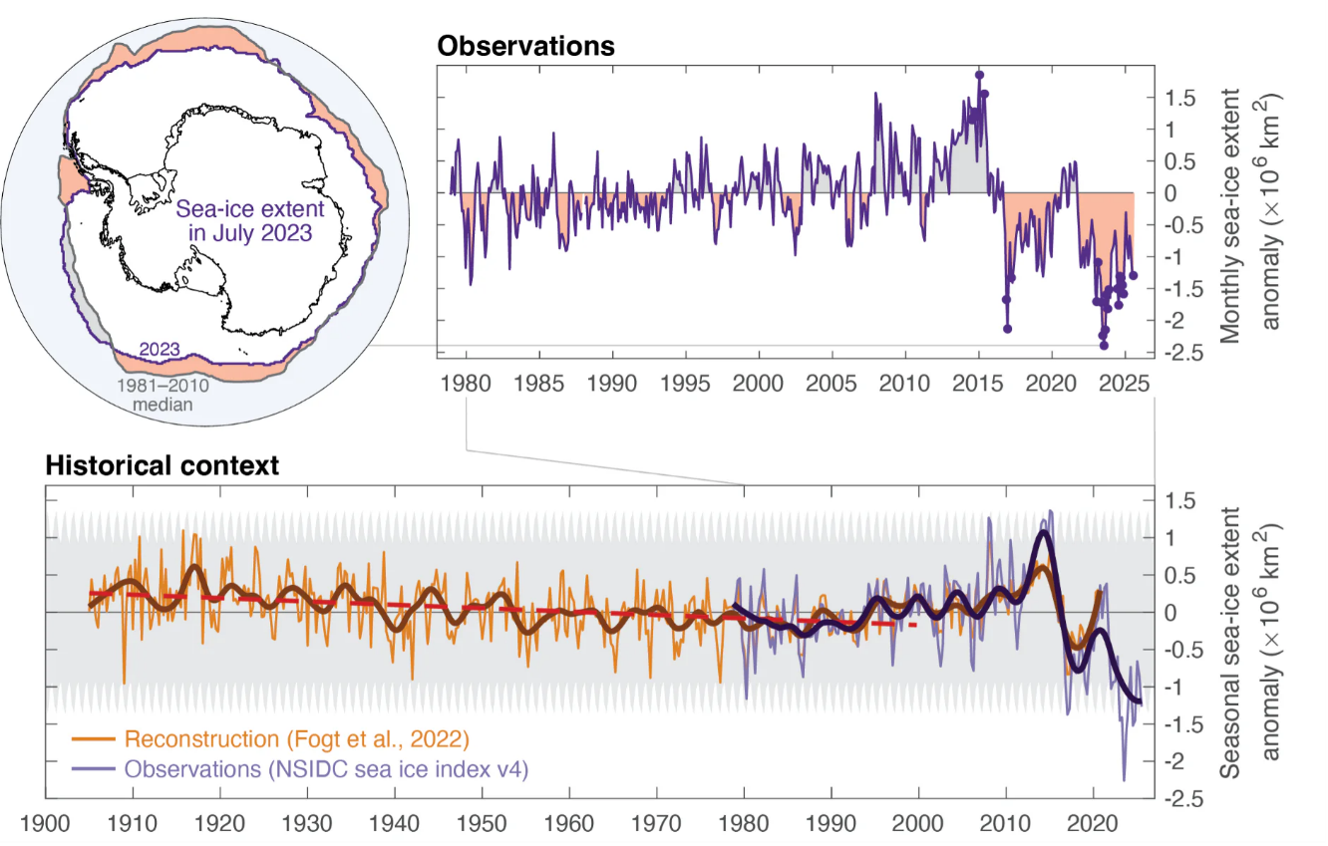

Figure 1 – a. Map: Sea-ice extent for July 2023 (red line) relative to 1981–2010 July median (blue line). Red (grey) shading shows regions where the sea-ice edge in July 2023 was farther South (North) than the 1981–2010 median. Observations: Antarctic sea-ice extent anomalies relative to 1981–2010. b. Historical context: Reconstructions confirm Antarctic sea ice underwent a long-term decline, but recent abrupt loss far exceeds this long-term decline and natural variability (Source: Abram et al. 2025).¹⁶
Drivers of Antarctic Sea-Ice Change
Key Message: Antarctic sea ice is sensitive to an array of complex and interlinked drivers; however, observations indicate that heat build-up in the Southern Ocean is the major driver of recent circumpolar-wide sea-ice declines.
Several interacting processes drive Antarctic sea‑ice variability and long‑term change. Among the most influential are increases in ocean heat content, ^{17,18} shifts in atmospheric circulation, including teleconnections with tropical climate, ^{19,20} and ocean memory from the previous year affecting in turn ice-ocean interactions.²¹ Observations indicate a sustained build‑up of heat in the upper Southern Ocean since at least ~1980, which is among the most significant drivers of sea-ice decline.^{18,22} This increased subsurface heat, combined with more vigorous vertical mixing driven by both oceanic and atmospheric processes, promotes the upward transport of warm water.^{18,22} This reduces sea‑ice growth and accelerates sea-ice loss.^{19,20}
The relative importance of individual drivers varies regionally and seasonally, and their combined effects are complex.^{12,15,23-25} Predicting the future of Antarctic sea‑ice change is challenging, however continued increases in ocean heat content are expected to drive further sea‑ice decline.^{2,3} Continued observations and research across all Antarctic sectors and seasons are needed to better disentangle these drivers and to understand how they will evolve in a warming climate.²⁶⁻²⁹
Ecological Impacts of Antarctic Sea-Ice Change
Key Message: Antarctic sea ice plays a key role in supporting Southern Ocean ecosystems. Observed sea-ice loss to date has had concerning ecological consequences.
Ecologically, sea ice provides essential habitat for a wide range of Antarctic flora and fauna, including breeding, feeding and refuge areas for species of penguins and ice-dependent seals (WP 034 and WP006). It also regulates important ecosystem processes via light availability, nutrient fluxes and CO₂ uptake by phytoplankton.^{1,7,27,30-32}
Most assessed impacts of sea-ice loss are largely negative (Figure 2).^{3,29} Sea-ice loss affects nutrient availability and therefore ecosystem composition and food webs.^{1,2,7,33,34} This has consequences for ecosystem structure, function, services and resource utilisation.^{1,27,35} Ecological impacts of sea-ice loss are highly variable with some regions and some species more vulnerable than others²⁸ (Figure 2). Observed impacts (Figure 2) range from prolonged open-water periods alternating the magnitude and timing of surface-phytoplankton blooms, to shifting food-web dynamics such as the distribution of Antarctic krill and salps,³⁶ and habitat loss and changes in prey availability for higher-trophic-level specie.s²⁹ Fast ice (sea ice that remains anchored to coastlines, ice shelves, or other grounding points) has also declined. This loss reduces critical habitat for emperor penguin breeding (WP 006)³⁷ and Weddell seal pupping,^{28,29} and exposes the coast to increased wave action and swell.³⁸ The resulting rise in coastal vulnerability heightens risks to ice shelves, near-shore ecosystems and coastal infrastructure.

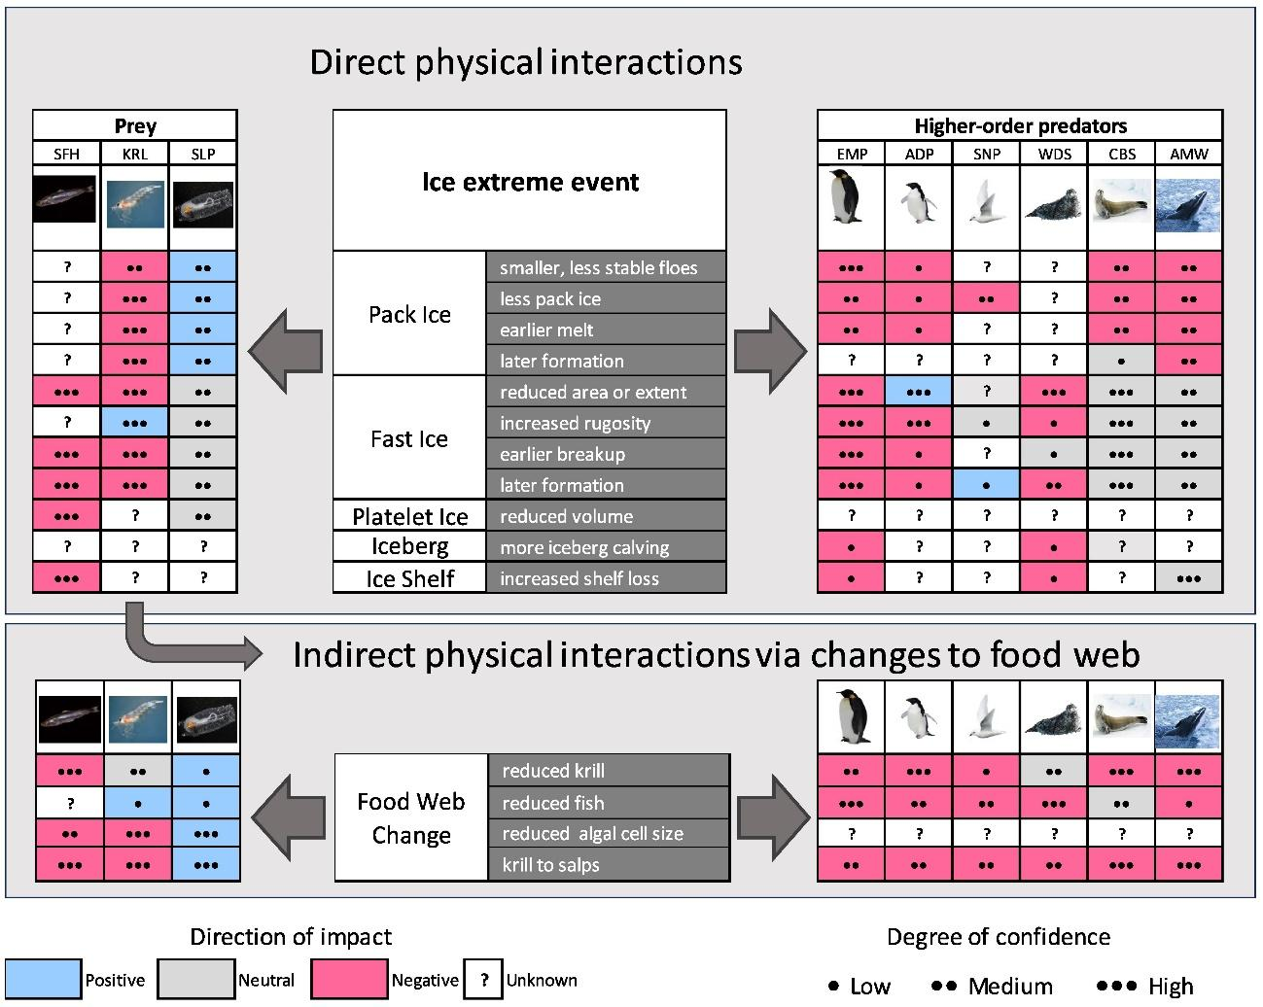

Figure 2 - Generalized response of higher-order predators and their prey to extreme events associated with sea ice (Source: Doddridge et al. 2025, PNAS). Image reproduced under a Creative Commons License: http://creativecommons.org/licenses/by/4.0/.
International Cooperation Urgently Needed
Key Message: Sea-ice changes will have global impacts. To respond effectively there is a need to strengthen international scientific collaboration, including to expand long-term monitoring, and accelerate advances in sea-ice modelling.
Globally, sea-ice loss can result in upwelling of warm, deep water onto the Antarctic continental shelf, ^{27,39} destabilising ice shelves,⁴⁰ leading to potentially unstoppable loss of over a third of Antarctica’s ice sheets and increased global sea-level rise.^{2,3} Reduced sea ice leads to less heat and carbon uptake by the Southern Ocean, increasing atmospheric CO₂ concentrations and accelerating global warming.^{1,2} Moreover, sea-ice loss weakens the global ocean circulation^{41,42} impacting equator-pole heat distribution, as well as Southern Ocean nutrient supply, that currently supports 75% of global ocean production.⁴³
The recent and in 300 years unprecedented decline in Antarctic sea ice is emerging as one of the clearest indicators that rapid and potentially irreversible change is underway. Strengthening observations to address remaining knowledge gaps, such as sea‑ice thickness, changes in snow cover, and the transmission of light to the underlying marine ecosystem, will improve projections of future sea‑ice trajectories and their implications for regional and global systems.
The upcoming Fifth International Polar Year (IPY5) and the Antarctica InSync initiative offer timely and powerful opportunities to mobilise international cooperation across all Antarctic regions and scientific disciplines. These efforts have a critical role in accelerating the collection of essential data, establishing long-term monitoring networks for key physical and ecological early warning indicators, and significantly improving the modelling capabilities needed to reduce uncertainties in future sea-ice projections.
Strengthening modelling capabilities must be a priority to better understand the processes, drivers, feedbacks, and impacts of Antarctic sea-ice change, both now and in the decades ahead. At the same time, building a robust and diverse research community is essential. Actively supporting the recruitment and development of new talent, particularly early-career researchers, will ensure the capacity and innovation required to meet the scale of the challenge.
Recommendations
Given the ongoing and predicted future changes in Antarctic sea-ice decline, and the potential impacts on Antarctic ecosystems and the Earth System, SCAR recommends that Members:
Continue to identify priority information needs related to Antarctic sea-ice change so that future updates from SCAR can focus on the most relevant research and provide advice on understanding and mitigating ongoing sea-ice change.
Support ongoing and increased observations related to sea ice to improve predictions and inform outcomes for system functioning, including for Antarctic marine life such as penguins and seals. This could include collaboration with Antarctica InSync (2027/28-2028/29) and be further developed for the 2032/33 IPY.

References
1 Chown, S. L. et al. Antarctic Climate Change and the Environment: A Decadal Synopsis and Recommendations for Action. (Scientific Committee on Antarctic Research, Cambridge, United Kingdom., 2022).
2 IPCC. Special Report on the Ocean and Cryosphere in a Changing Climate 755 (2019).
3 IPCC. Climate Change 2021: The Physical Science Basis. Contribution of Working Group I to the Sixth Assessment Report of the Intergovernmental Panel on Climate Change 2391 (2021).
4 Fogt, R. L., Sleinkofer, A. M., Raphael, M. N. & Handcock, M. S. A regime shift in seasonal total Antarctic sea ice extent in the twentieth century. Nature Climate Change 12, 54-62 (2022).
5 Roach, L. A. et al. Antarctic sea ice area in CMIP6. Geophysical Research Letters 47, e2019GL086729 (2020).
6 Simmonds, I. Comparing and contrasting the behaviour of Arctic and Antarctic sea ice over the 35 year period 1979-2013. Annals of Glaciology 56, 18-28 (2015).
7 Ackley, S. et al. Sea-ice production and air/ice/ocean/biogeochemistry interactions in the Ross Sea during the PIPERS 2017 autumn field campaign. Annals of Glaciology 61, 181-195 (2020).
8 Parkinson, C. L. A 40-y record reveals gradual Antarctic sea ice increases followed by decreases at rates far exceeding the rates seen in the Arctic. Proceedings of the National Academy of Sciences 116, 14414-14423 (2019).
9 Eayrs, C., Li, X., Raphael, M. N. & Holland, D. M. Rapid decline in Antarctic sea ice in recent years hints at future change. Nature Geoscience 14, 460-464 (2021).
10 Raphael, M. N. & Handcock, M. S. A new record minimum for Antarctic sea ice. Nature Reviews Earth & Environment 3, 215-216 (2022).
11 Abram, N. J. et al. Emerging evidence of abrupt changes in the Antarctic environment. Nature 644, 621-633, doi:10.1038/s41586-025-09349-5 (2025).
12 Reid, P. A. & Massom, R. A. Change and variability in Antarctic coastal exposure, 1979–2020. Nature Communications 13, 1164, doi:10.1038/s41467-022-28676-z (2022).
13 Gilbert, E. & Holmes, C. 2023's Antarctic sea ice extent is the lowest on record. Weather 79, 46-51, doi:https://doi.org/10.1002/wea.4518 (2024).
14 NOAA., N. S. a. I. D. C. a. Sea ice Index Version 3 (G02145), <https://nsidc.org/data/g02135> (February 2024).
15 Raphael, M. N., Maierhofer, T. J., Fogt, R. L., Hobbs, W. R. & Handcock, M. S. A twenty-first century structural change in Antarctica’s sea ice system. Communications Earth & Environment 6, 131 (2025).
16 Abram, N. et al. Emerging evidence of abrupt changes in the Antarctic environment. Antarctic Environments Portal (environments.aq), doi:https://doi.org/10.48361/Q2P7-G949 (2025).
17 Josey, S. A. et al. Record-low Antarctic sea ice in 2023 increased ocean heat loss and storms. Nature 636, 635-639, doi:10.1038/s41586-024-08368-y (2024).
18 Purich, A. & Doddridge, E. W. Record low Antarctic sea ice coverage indicates a new sea ice state. Communications Earth & Environment 4, 314, doi:10.1038/s43247-023-00961-9 (2023).
19 Himmich, K. et al. Drivers of Antarctic sea ice advance. Nature Communications 14, 6219, doi:10.1038/s41467-023-41962-8 (2023).
20 Morioka, Y. et al. Antarctic sea ice multidecadal variability triggered by Southern Annular Mode and deep convection. Communications Earth & Environment 5, 633, doi:10.1038/s43247-024-01783-z (2024).
21 Docquier, D. et al. Drivers of summer Antarctic sea-ice extent at interannual time scale in CMIP6 large ensembles based on information flow. Climate Dynamics 63, 374, doi:10.1007/s00382-025-07878-3 (2025).
22 Cheng, L. et al. Ocean heat content in 2023. Nature Reviews Earth & Environment 5, 232-234 (2024).
23 Stammerjohn, S. et al. in Antarctica and the Earth System 115-140 (Routledge, 2025).
24 Holmes, C., Doddridge, E. W. & Fretwell, P. Antarctic Sea Ice #4: Record lows between 2022 and 2025. Antarctic Environments Portal (environments.aq), doi:https://doi.org/10.48361/KVK6-ZX15 (2025).
25 Wilson, E. A., Arlen, L. & Campbell, E. C. Recent extremes in Antarctic sea ice extent modulated by ocean heat ventilation. Proceedings of the National Academy of Sciences 123, e2530832123, doi:10.1073/pnas.2530832123 (2026).
26 Cavanagh, R. et al. Utilising IPCC assessments to support the ecosystem approach to fisheries management within a warming Southern Ocean. Marine Policy 131, 104589 (2021).
27 Cavanagh, R. et al. Future Risk for Southern Ocean Ecosystem Services Under Climate Change. Frontiers in Marine Science 7, doi:10.3389/fmars.2020.615214 (2021).
28 Krumhardt, K. M. et al. Emergent climate change signals within Antarctic sea ice and associated ecosystems. Nature Climate Change 16, 364-371, doi:10.1038/s41558-026-02561-9 (2026).
29 Doddridge, E. W. et al. Impacts of Antarctic summer sea-ice extremes. PNAS Nexus 4, doi:10.1093/pnasnexus/pgaf164 (2025).
30 Eayrs, C. et al. Understanding the Seasonal Cycle of Antarctic Sea Ice Extent in the Context of Longer‐Term Variability. Reviews of Geophysics 57, 1037-1064 (2019).
31 Gutt, J. et al. Antarctic ecosystems in transition–life between stresses and opportunities. Biological Reviews 96, 798-821 (2021).
32 Clem, K., Massom, R., Stammerjohn, S. & Reid, P. Antarctic Sea Ice #2: Biological Importance. Antarctic Environments Portal (environments.aq), doi:https://doi.org/10.48361/8tky-2793 (2022).
33 Convey, P. & Peck, L. S. Antarctic environmental change and biological responses. Science Advances 5, eaaz0888 (2019).
34 Corso, A. D., Steinberg, D. K., Stammerjohn, S. E. & Hilton, E. J. Climate drives long-term change in Antarctic Silverfish along the western Antarctic Peninsula. Communications biology 5, 1-10 (2022).
35 Fretwell, P. T., Boutet, A. & Ratcliffe, N. Record low 2022 Antarctic sea ice led to catastrophic breeding failure of emperor penguins. Communications Earth & Environment 4, 273, doi:10.1038/s43247-023-00927-x (2023).
36 Atkinson, A. et al. Implications of the recent loss of Antarctic sea ice for phytoplankton and summer feeding habitats of salps and krill. Marine Ecology Progress Series 774, 1-16 (2025).
37 Fretwell, P., Bamford, C., Skachkova, A., Trathan, P. & Forcada, J. Regional emperor penguin population declines exceed modelled projections. Communications Earth & Environment 6, 436 (2025).
38 Massom, R. et al. The influence of ocean waves on Antarctic sea-ice albedo and seasonal melting, and physical-biological feedbacks. (2025).
39 Silvano, A. et al. Recent recovery of Antarctic Bottom Water formation in the Ross Sea driven by climate anomalies. Nature Geoscience 13, 780-786 (2020).
40 Massom, R. A. et al. Antarctic ice shelf disintegration triggered by sea ice loss and ocean swell. Nature 558, 383-389 (2018).
41 Zhou, S. et al. Slowdown of Antarctic Bottom Water export driven by climatic wind and sea-ice changes. Nature Climate Change 13, 701-709, doi:10.1038/s41558-023-01695-4 (2023).
42 Rintoul, S. R. et al. Antarctic Bottom Water in a changing climate. Nature Reviews Earth & Environment 7, 86-102, doi:10.1038/s43017-025-00750-2 (2026).
43 Rintoul, S. R. The global influence of localized dynamics in the Southern Ocean. Nature 558, 209-218, doi:10.1038/s41586-018-0182-3 (2018).

