Battlefield euthanasia: Can we let our soldiers opt for it?
Ref: https://www.dnaindia.com/analysis/column-battlefield-euthanasia-can-we-let-our-soldiers-opt-for-it-2622412
Battlefield euthanasia is a related issue that needs to be discussed: Should a gravely wounded soldier, who has no possibility of recovery, be killed in the battlefield?
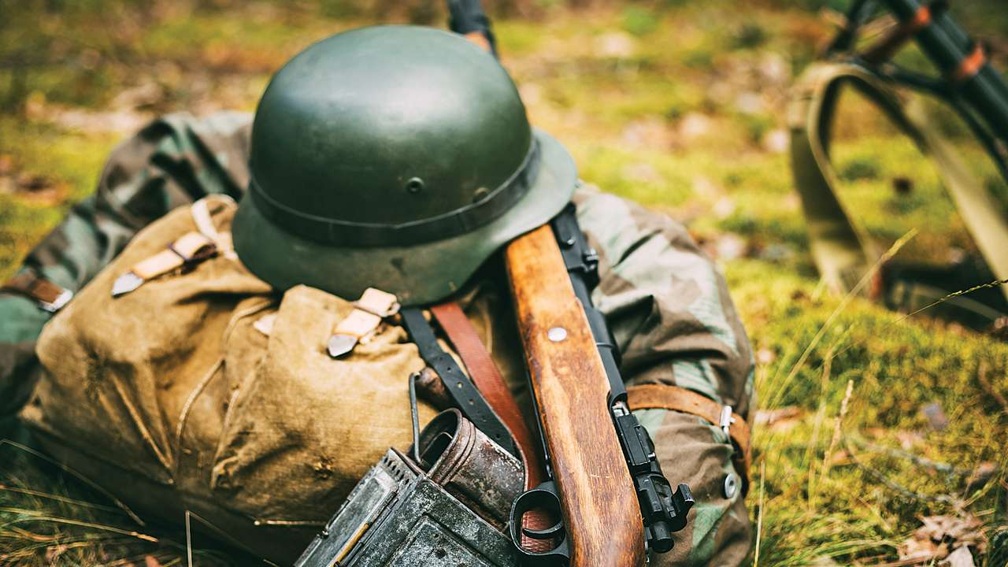
Updated: Jun 6, 2018, 03:15 AM IST
On March 9, 2018, the Constitution Bench of the Supreme Court, while deciding a writ petition under Article 32 of the Constitution, legalised passive euthanasia. The Court considered the international position on euthanasia and stated that it would be allowed only when the patient is in sound mind and has the ability to make an informed decision. Battlefield euthanasia is a related issue that needs to be discussed: Should a gravely wounded soldier, who has no possibility of recovery, be killed in the battlefield? There were a number of instances in WW-I, WW-II and the Vietnam War, where combatants resorted to mercy killing. Senior British military officers, who participated in the Falkland War, have revealed that badly wounded Argentinean soldiers were killed by the British troops to “end their suffering”. A British soldier was exonerated for his act of mercy and another administered a lethal dose of morphine to his best friend who had been injured by a bomb.
In the recent past, a few cases of mercy killing have been reported from Afghanistan and Iraq. Sergeant Colin Maclachlan, a former British Special Force (SAS) member, has mentioned in his book, SAS Who Dares Wins: Leadership Secrets from The Special Forces, how he killed a few mortally wounded enemy soldiers on the Syrian border in 2003. He has narrated how after a SAS squad fired rockets at enemy units, he discovered two Iraqi soldiers who had been disembowelled and another who had lost three limbs. According to Maclachlan, the injured soldiers were “pleading for us to do it” and the SAS personnel “quickly put them out of their misery, rather than leaving them to die slowly and in agony”. Executing wounded enemy troops on the battlefield, even when intended as a ‘mercy killing’, is illegal under the UK’s military law. The Ministry of Defence had launched an inquiry into the matter, but further details have not been revealed.
The US forces also resorted to mercy killings in the Iraq war in 2004. In one incident, an insurgent, who was gravely wounded during a vehicle chase, was shot twice in the head to end his suffering. At his trial, Captain Maynulet, who had killed the insurgent stated, “He was in a state that I didn’t think was dignified. I had to put him out of misery. It was the right, the honourable thing to do.” The court martial acquitted Maynulet of assault with intent to commit murder, but found him guilty of the lesser offence of assault with intent to commit voluntary manslaughter. In another incident, an Iraqi teenager, who was gravely wounded, was shot dead by two sergeants. The sergeants were later tried by a court-martial, convicted of murder, and sentenced to prison. In October 2008, Captain Robert Semrau of the Canadian Forces fired two rifle shots into the chest of a seriously-wounded Taliban fighter. A military court acquitted Semrau of murder, but found him guilty of ‘disgraceful conduct’. He was demoted and dismissed from service.
International law is very clear on this issue: No soldier or physician is authorised to kill gravely wounded comrades, or wounded enemies, who no longer pose an immediate threat to them. The first Geneva Convention of 1949 stipulates in Article 12: “Members of the armed forces … who are wounded or sick, shall be respected and protected in all circumstances. They shall be treated humanely and cared for by the Party to the conflict in whose power they may be. Any attempts upon their lives, or violence to their persons, shall be strictly prohibited…; they shall not wilfully be left without medical assistance and care... The Party to the conflict, which is compelled to abandon wounded or sick to the enemy shall, as far as military considerations permit, leave with them a part of its medical personnel and material to assist in their care.” The Geneva Conventions have universal ratification and States are bound to enforce them in their own military laws and regulations.
There are a few who argue that certain instances of battlefield euthanasia are not only morally justifiable, but are more ethical than allowing someone to die in agony and distress from their wounds. For instance, where it is impossible to evacuate patients and dangerous and medically futile to remain with them, medics may have to choose between abandonment and euthanasia. Those who support this argument suggest changes in military laws to permit mercy killing.
Professional codes of ethics have traditionally prohibited physicians and military doctors from directly and intentionally killing patients under any circumstances. In countries where voluntary euthanasia is legal, complex processes exist to ensure that patient consent is valid and appropriate. In war, such judicial process or peer review is seldom available. The confusion, fatigue, fear, hopelessness and fear of future suffering may influence decision making during an armed conflict. It is necessary to keep the rule for soldiers very simple: Not to kill anybody who’s not a threat. It would be unfair to ask soldiers to bear the burden of making euthanasia decisions or carrying them out, given the pressures and trauma of armed conflicts.
The author is a retired Wing Commander. Views are personal.

Battlefield euthanasia — courageous compassion or war crime?
Ref. https://www.mja.com.au/journal/2011/194/6/battlefield-euthanasia-courageous-compassion-or-war-crime
Susan J Neuhaus
Med J Aust 2011; 194 (6): 307-309. || doi: 10.5694/j.1326-5377.2011.tb02980.x
Published online: 21 March 2011

Abstract
- Issues relating to voluntary euthanasia that are currently being debated by Australian society are distinctly different from those encountered by battlefield doctors.
- Doctors in war undertake to treat those affected by conflict; their participation in euthanasia challenges the profession’s definition of “duty of care”.
- Euthanasia must be distinguished from “triage” and medical withdrawal of care (which are decided within a medical facility where, although resources may be limited, comfort care can be provided in the face of treatment futility).
- Battlefield euthanasia is a decision made, often immediately after hostile action, in the face of apparently overwhelming injuries; there is often limited availability of pain relief, support systems or palliation that would be available in a civilian environment. The battlefield situation is further complicated by issues of personal danger, the immediacy of decision making and difficulties with distinguishing civilians from combatants.
- Regardless of the circumstances on a battlefield, doctors, whether they are civilians or members of a defence force, are subject to the laws of armed conflict, the special provisions of the Geneva Conventions and the ethical codes of the medical profession.
The act of killing controverts the healing purpose of medicine
Pellegrino1
Throughout history, doctors within both military and humanitarian organisations have, often under the most difficult circumstances, endeavoured to treat the injuries and suffering of those affected by war. The modern battlefield is characterised by serious injuries, including critical and incapacitating wounds, multiple amputations and severe burns among not only soldiers but also civilians. Treatment may not be technically or physically available, medical support systems may be inadequate and there may be no options to transfer the injured to other facilities for care. Doctors in war are frequently required to make complex decisions about the limitations and appropriateness of medical treatment, and to deal with the seemingly contradictory demands of preserving life and relieving suffering.2
In this article, I seek to explore the unique roles and responsibilities of battlefield doctors, specifically in the ethical dilemma of battlefield euthanasia.

History of battlefield euthanasia
The first recorded case of battlefield euthanasia is biblical,3 but the first recorded case involving a physician (albeit indirectly) was that of Ambroise Paré in 1537, after the fall of Turin.4 On encountering mortally wounded enemy soldiers, a senior French soldier “cut their throates gently”. This act horrified Paré, but he was, in turn, reprimanded by the soldier:
he answered me that he prayed God, that whenever he should be in such a case .... he might find someone that would do as much to him, [that] he might not miserable languish.4
In 1799, Napoleon’s physician René-Nicolas Desgenettes was similarly horrified by an order (which he refused) to give lethal doses of opium to soldiers dying from bubonic plague, rather than leave them to the mercy of the advancing Marmeluk Army.5 In contrast, during World War II, Jewish physicians decided to administer hydrogen cyanide to four patients unable to be moved from their hospital beds, in order to spare them the expected brutality and death at the hands of the Sonderkommando.6 Of note, in this case, although supervised by the doctors, it was left to a nurse to act as the direct agent of death.
Also during World War II, Lieutenant Colonel John Masters recounted an episode when he and his surgeon were confronted with severely wounded soldiers in the face of advancing Japanese:7
The doctor said, “I’ve got another thirty on ahead, who can be saved, if we can carry them. These men have no chance. None can last another two hours, at the outside.”
I said aloud, “Very well. I don’t want them to see any Japanese.” Shells and bombs burst on the slope above and bullets clattered and whined overhead.
“Do you think I want to do it?” the doctor cried in helpless anger. “We can’t spare any more morphia.”
“Give it to those whose eyes are open,” I said. “Get the stretcher bearers on at once. Five minutes.”
He nodded and I went back up to the ridge, for the last time. One by one, carbine shots exploded curtly behind me. I put my hands to my ears but nothing could shut out the sound.
There are few examples of civilian situations in which issues like these are confronted, although it is conceivable that natural disasters or a terrorist attack could produce both the overwhelming casualties and the breakdown of medical support structures required to produce such a scenario. In the days following Hurricane Katrina in August 2005, a doctor and two nurses were arrested on charges of homicide involving patients in Memorial Medical Centre, Louisiana. The hospital’s capacity to provide standard medical care for its patients had been crippled. Patients and refugees were crowded together for days with no lighting, no elevators, no toilets, no running water, no refrigeration or air conditioning, and no telephones. Evacuation had been slow and hundreds remained, including the sickest patients who could not be moved. Some clinicians were said to have ended the lives of some patients before leaving the hospital themselves.8
Definitions and distinctions
The term euthanasia derives from the Greek — “good death”. There are many caveats on the term, but it is most usefully defined as “a deliberate intervention undertaken with the express intention of ending a life, to relieve intractable suffering”.9
Euthanasia, particularly in a military setting, must be distinguished from “triage”, which provides an ethical framework for deciding on priorities of care in resource-limited (predominantly mass-casualty) environments. There is no doubt that in these situations, patients with overwhelming injuries may be triaged to “expectant care”. The overriding priority in all such cases is care, compassion and respect for human dignity and human life. The patient is provided with comfort until he or she either dies or the situation changes and resources become available to provide treatment.
Similarly, it is important to distinguish euthanasia from discontinuing life-prolonging measures (eg, removing ventilators) in situations where death is an inevitable consequence. These decisions are based on the futility of ongoing medical treatment and on the potential harm of continuing care. Although the outcome is the same — the death of the patient — the distinction lies in intent, method and responsibility.10,11
Although each of these raises its own ethical complexities, particularly in war, I will not discuss them further here.

Moral questions and medical accountability
The historical cases illustrate the complexity of a doctor’s position in considering euthanasia in war. No one would doubt the agony or overriding compassionate intent that lies behind a soldier taking such a decision on behalf of a comrade, but the involvement of doctors, as physicians and healers, in such acts is less morally clear.
Doctors have long considered themselves bound by the key tenet of the Hippocratic oath “primum non nocere” (first do no harm). Over time, some prohibitions within the oath have been removed, including those to surgery and abortion. Although morally offensive to many doctors, it is possible that, in the future, the profession may lift prohibitions to doctor-assisted suicide. Of note however, even in Hippocrates’ time, the Greeks permitted euthanasia or suicide as an alternative to a lingering and painful death.12,13 It is the specific involvement of physicians which was proscribed.
The underpinning ethical principles involved in battlefield euthanasia are primarily questions of patient autonomy, beneficence (doing good) and non-maleficence (not doing harm). This presupposes that there is a simple choice between preserving life and relief of suffering. However, the immediate needs of a suffering human cannot be ignored, and complex and difficult choices must be made.14
Autonomy (an individual’s right to determine his or her outcome) is inevitably compromised in times of war. Soldiers are obliged to follow orders, civilians live under conditions of martial law and/or occupation — all parties are subject to circumstances that deny freedom of action.
In the Netherlands, where voluntary euthanasia is legal, complex processes exist to ensure that patient consent is valid and appropriate.15 In war, such judicial process or peer review is seldom available. The confusion of war, the impact of fatigue, fear, hopelessness and fear of future suffering will inevitably influence the clarity of decision making. In a controlled elective situation, it is considered imperative to exclude patients who have depression from euthanasia. In a country at war, the effect of endured privations, occupation and atrocities could be argued to produce a kind of collective depression that extinguishes hope for the future.
In both the Napoleonic War and World War II examples provided above, euthanasia was justified, in part, by the desire to avoid a greater suffering — that promised by capture or torture by an encroaching enemy force. However, it is necessary to question the certainty of that future outcome and to discount the effects of rumour or flawed intelligence.
In none of the examples above was there clear consent from the patients. It could be argued that, even if they had requested otherwise, it may still be in their best interests to be killed painlessly and not abandoned to the enemy. This represents a slippery slope from non-voluntary euthanasia (where the patient is unable to request) into involuntary euthanasia (where the patient is able to request, but is not consulted and their views are not respected).12
Unique position of the doctor
Regardless of the moral arguments for and against euthanasia in a battlefield setting, the issue of medical involvement must be addressed separately. Doctors hold a unique position of trust in the community. Participation by doctors in euthanasia carries a grave risk of undermining public trust in the profession. Many would consider that:
even if a dying person is pleading for the relief that only death can promise, a clinician who kills a patient arguably betrays his or her commitment to their [doctor–patient contract].8
A further concern is the potential for role confusion, applicable particularly to uniformed doctors; the distinction between a doctor acting in the interest of the patient or becoming an instrument of political or military purpose.1 Throughout history, states have sought medical legitimacy and complicity for corrupt purposes, the most notable being the Nazi regime.16 Equally, euthanasia involving potential witnesses against war crimes, or to avoid sensitive military information falling into enemy hands, constitutes politically motivated murder.
Some authors argue that, provided doctors are given a “moral distance”, physician complicity in euthanasia can be justified in some circumstances.14,17 This raises questions about whether there is a distinction between the doctor as the instrument of death and the arbitrator of death — is it possible to remove the doctor from the act, if not from the decision of death?
Another consideration is the method of death. Many modern modalities can alleviate pain and suffering, although, admittedly, not all are available or in ready supply on the battlefield. It could be argued (as was justified in Master’s case,7 above) that using a scarce resource (eg, morphine) in the face of expected large numbers of future patients may be inappropriate. It may be necessary to use a weapon instead.17
Two courts martial demonstrate the difficulties in distinguishing intent to relieve suffering, or mercy killing, from deliberate killing of wounded (enemy) combatants. In 2005, a United States army officer was convicted of “assault with intent to commit voluntary manslaughter” after shooting a wounded Iraqi insurgent.18 In 2010, a Canadian officer was found guilty of “disgraceful conduct” after allegedly shooting an unarmed Taliban soldier in Afghanistan.19 Neither incident involved doctors, although the defendant in the latter court martial “acted on advice of the medic”. Conversely, recently published memoirs of an Australian surgeon describe shooting a woman, mortally wounded in Kosovo in 1999, and again raise issues of the unique role and obligations of a doctor.20

Doctors’ obligations in war — the laws of armed conflict
As with civil society, war is governed by rules. Australia is a signatory to the Geneva Conventions, which are binding. The actions and responsibilities of doctors are covered in the special provisions of the Conventions, and form the basis of ethical military medical practice.2,21 In essence, there are three conditions:
- first, doctors may not partake in direct combat activities;
- second, doctors must treat all casualties of war on the basis of medical priority without regard for their status as enemy, coalition or civilian; and
- third, doctors have a moral responsibility to speak out against atrocities committed by any party.
The Geneva Conventions (First Geneva Convention, Articles 12 and 15; Second Geneva Convention, Articles 12 and 18; Protocol 1, Article 10 and Protocol 2, Article 7) prohibit euthanasia.
Doctors serving with the Australian Defence Force are governed by both Australian military regulations and Status of Forces Agreements, making them accountable for acts committed on overseas territory or involving foreign nationals.22 Australian nationals serving in overseas conflict may equally be accountable to that nation’s legislation. Australian legislation (Euthanasia Laws Act 1997 [Cwlth]), while allowing for palliative care and withdrawal of life-prolonging treatment, prohibits intentional killing of a patient.23

Conclusions
War is the ultimate failure of human relations. When participating in war, the moral principles enshrined in Australian law and in the Geneva Conventions apply regardless of the circumstances of the conflict. No doctor would wish to be placed in the invidious position represented in this article. For those who have made such choices, we can only have compassion.
When a society goes to war, it is to uphold and enforce its values over those of another society. Doctors hold an important role in society and in providing care for those harmed by the consequences of war. It is imperative that doctors’ professional values and ethical and legal responsibilities in these difficult circumstances are clear.

